**Lesson Topic: Consent and the Law**

Objectives:

* Define consent, coercion and incapacitated
* Differentiate between a situation in which consent is clearly given and one in which it is not
* Demonstrate understanding that clear consent is part of a respectful relationship
* Describe characteristics of relationship abuse
* Name at least two resources a rape, sexual or relationship abuse survivor can access for more information and support

**Activities:**

Videos:

* + “2 Minutes Will Change the Way You Think About Consent” <https://www.youtube.com/watch?v=laMtr-rUEmY>
  + “Tea Consent” <https://www.youtube.com/watch?v=fGoWLWS4-kU&t=84s>
  + “Pitch Perfect 2 Trailer-Ellen Show Version” (2:10-2:27) <https://www.youtube.com/watch?v=KBwOYQd21TY>

Develop a working definition of consent, coercion and incapacitated

Review Sexual Assault, Statutory Rape, and Sexual Harassment in accordance with NV law.

5 Types of Relationship Abuse

Makings of a Healthy Relationship

If you Think Your Relationship is Unhealthy

Is it Abuse If…? T/F activity

Slide 2

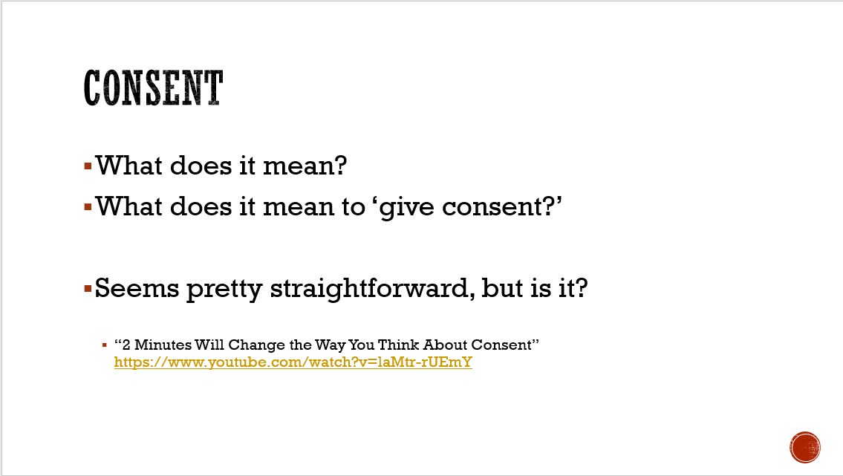

Consent-

* What does it mean?
* What does it mean to ‘give consent?’
  + Possible responses:
    - It’s when someone says they want to do something
    - When someone gives permission to another person
    - Saying “yes” to or being okay with something

It seems like consent is a pretty straightforward idea, but is it?

Slide 3

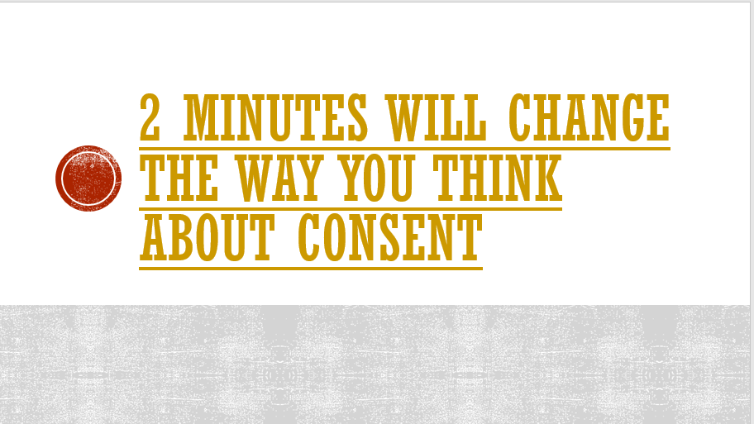

* + Play video: “2 Minutes Will Change the Way You Think About Consent” <https://www.youtube.com/watch?v=laMtr-rUEmY>

Ask for student reactions to the video

Slide 4

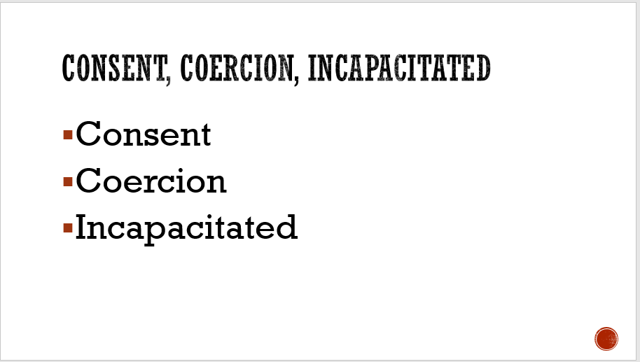

Process using the following:

The ConsentBot says her first attempt was “**coercion.”** What does that mean? (Probe

for getting someone to do something by threatening or forcing them). What did she

do that was coercive? Remind the students that, as the ConsentBot says, “Consent

must be voluntary,” which means a person has to want to give consent.

• When she goes to visit her friend, Jonathan, Jonathan is half asleep when she asks

for his phone and he says yes. The ConsentBot says it’s not consent because he’s

“**incapacitated**.” What does that mean? (Probe for when someone doesn’t have the

capacity or ability to do things – or say they want to do things). Jonathan was asleep,

so he would not have been completely aware of what he was saying. The same thing

goes if someone were drunk or using drugs.

• What do you think of the example when she is in the library and asks the person

wearing the headphones for their phone and they don’t respond -- and she assumes

she has consent because that person didn’t say no? Ask, “Why isn’t that the same

as having consent?” Probe for the importance of getting a clear “yes” or “no” from

someone to know for sure whether you have (or have not gotten) consent.

• Has anyone ever been in a situation where they haven’t wanted to do something,

but a friend has said, “It’s fine, just do it.” How has that felt? Why did the ConsentBot

say it wasn’t consent? (Probe for the fact that the middle person seemed to have felt

intimidated – meaning, pressured to do it, even if he wasn’t being pressured by the

person asking for consent).

• What did you notice in the last exchange, which the ConsentBot finally agrees is

consent? Probe for the fact that she asked – and he said yes, while also clarifying his

conditions: “You can use my phone, but no texts or international calls.” She clarified

by asking about his phone’s game center, and he responded. The ConsentBot said

that this was clear consent – and it was also healthy, clear communication.

“That was about using someone’s phone. Now, let’s take a look at a brief clip that has to do with sexuality and consent.”

Slide 5

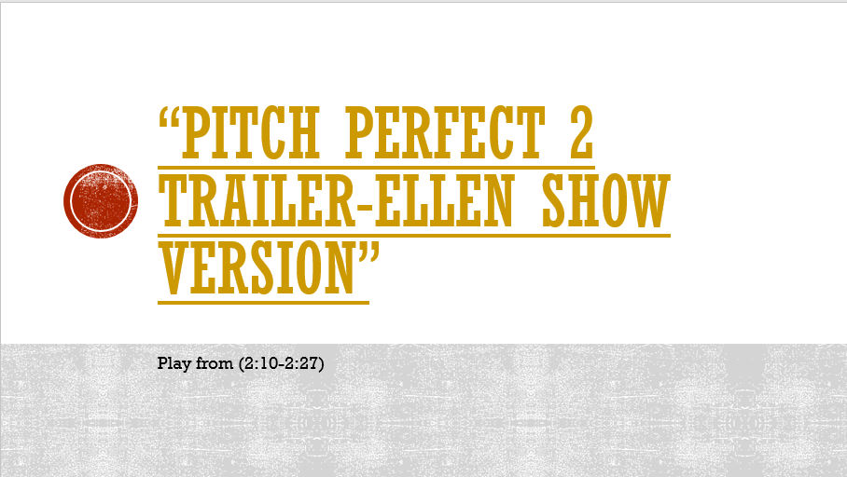

* + Play video: “Pitch Perfect 2 Trailer-Ellen Show Version” (2:10-2:27) <https://www.youtube.com/watch?v=KBwOYQd21TY>

After the clip ask…

* What did you just see? (possible responses: two people flirting at a party, miscommunication)
* When he asked her if she wanted to have sex, how did she respond? (She said she didn’t want to, but then winked at him; she said a clear no, but how she said it made him think she wanted to).
* How was he feeling then? (confused, hopeful, worried)
* Did she give her consent to him to have sex? (no)
* What do you think he should do next? (Walk away, ask her again, try something to see whether she’s interested).
* The smartest thing he can do is take her no as her answer. It doesn’t matter how she said it, but he has to go with what she actually said.
  + This is also a good example of why talking about consent at a party –where there is alcohol and/or drugs- isn’t the best place to talk about consent. What impact could alcohol or other drugs have on a person’s ability to clearly understand what someone is communicating to them?

Slide 6

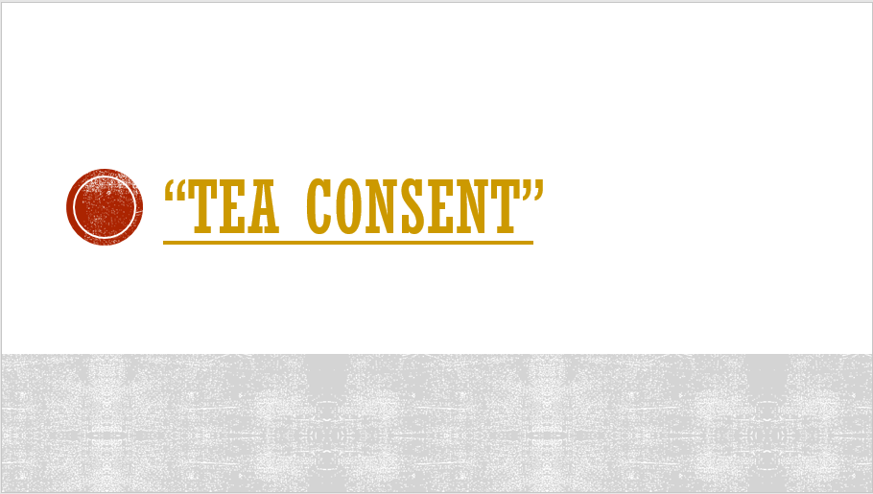

Talking about consent, let’s watch:

Play video: “Tea Consent” <https://www.youtube.com/watch?v=fGoWLWS4-kU&t=84s>

Slide 7:

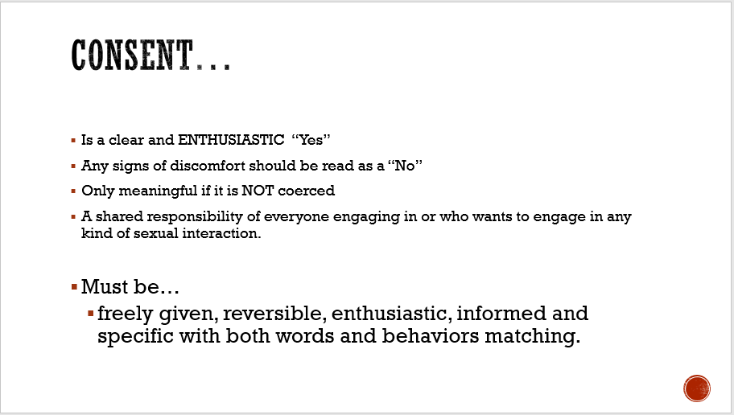

* It’s good to remember that anything other than a clear and enthusiastic ‘yes’ means NO.
* Must be freely given, reversible, enthusiastic, informed and specific with both words and behaviors matching.
* Any signs of discomfort should be read or interpreted as a “No”
* Only meaningful if it is NOT coerced

Consent is reaching and being in agreement about which things we want to do or explore with others sexually and how we want to do or explore those things.

It’s also about what we don’t want to do and how we don’t want to do something.

Active consenting is a shared responsibility of everyone engaging in or who want to engage in any kind of sexual interaction.

# S.E.X., second edition: The All-You-Need-To-Know Sexuality Guide to Get You Through Your Teens and Twenties

by [Heather Corinna](https://www.barnesandnoble.com/s/%22Heather%20Corinna%22;jsessionid=2817AA5423681F35560FFF1D65EBDA70.prodny_store02-atgap11?Ntk=P_key_Contributor_List&Ns=P_Sales_Rank&Ntx=mode+matchall)

Given what we now understand about consent, is there a legal age of consent?

Let’s talk about the law (information provided from Nevada Public Health Foundation)

Slides 8-21

Age of Consent

Statutory Rape

Sexual Assault

Reporting and Forensics exam

Sexual Harassment

Who to call for help

Slide 8:

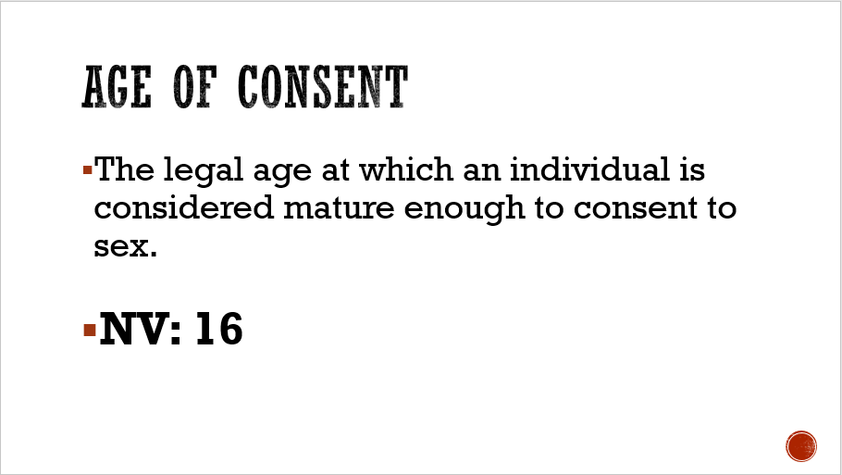

Slide 9:

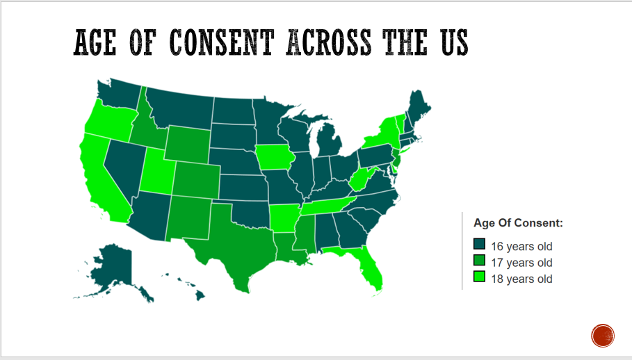

Slide 10:

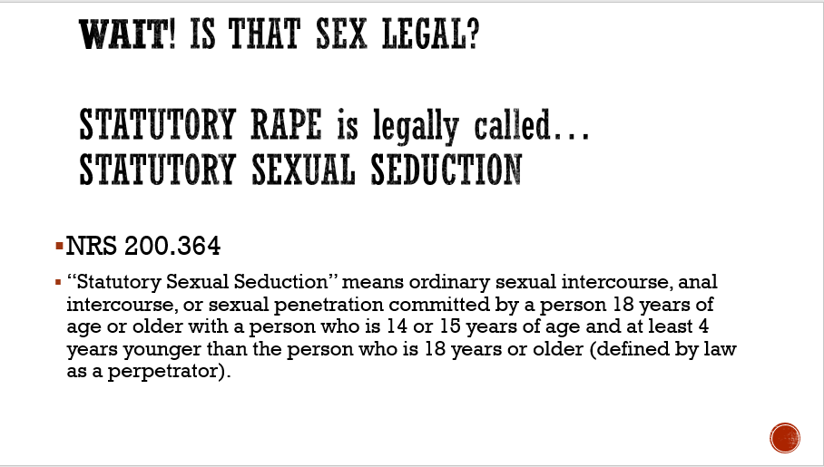

Slide 11:

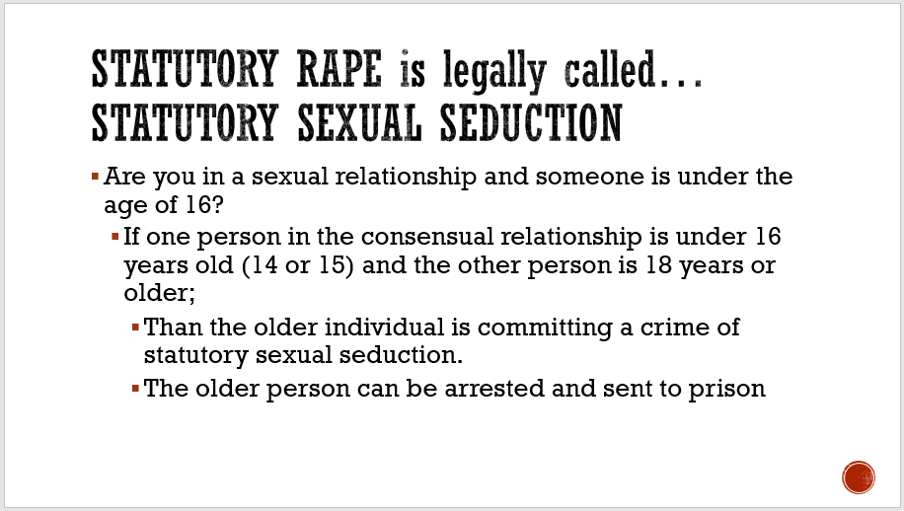

Slide 12:

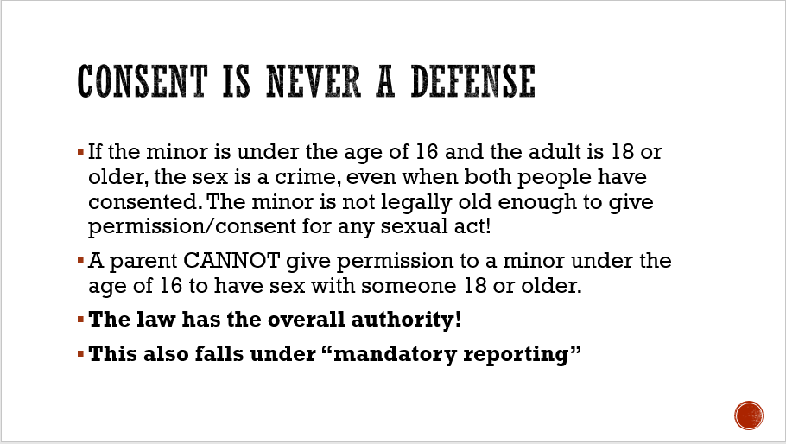

Slide 13:

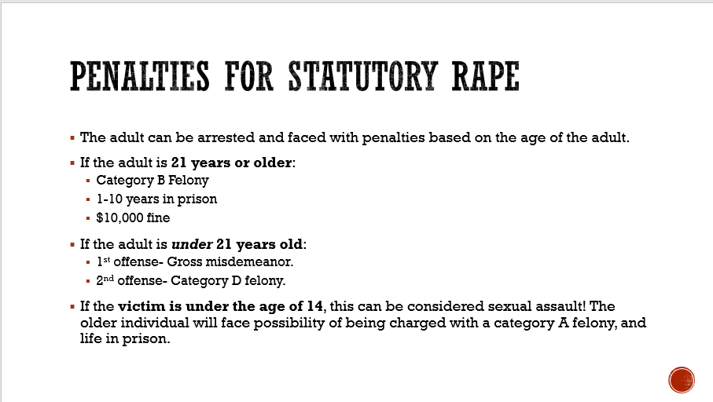

Slide 14:

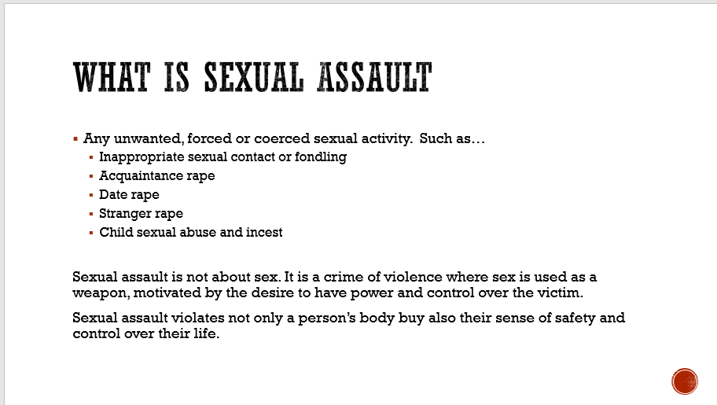

Slide 15:

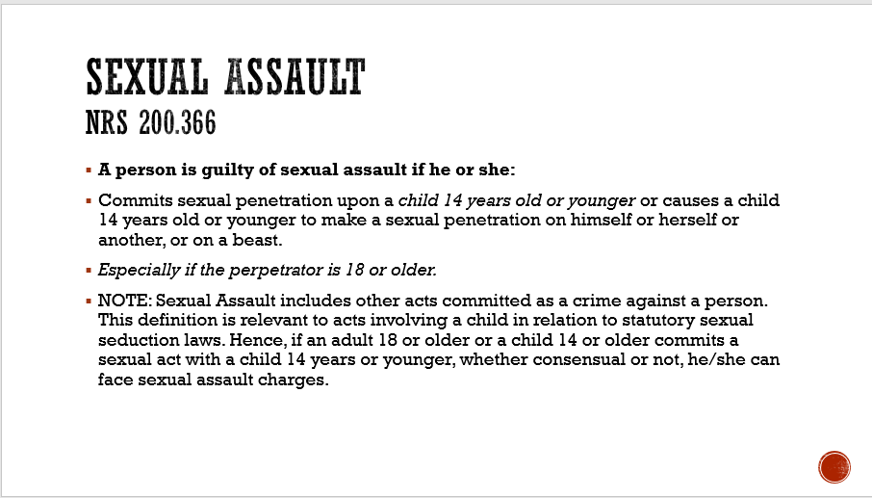

Slide 16:

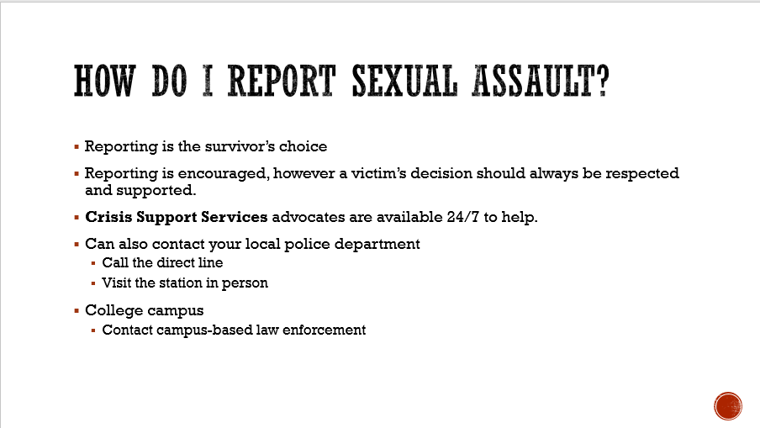

Slide 17:

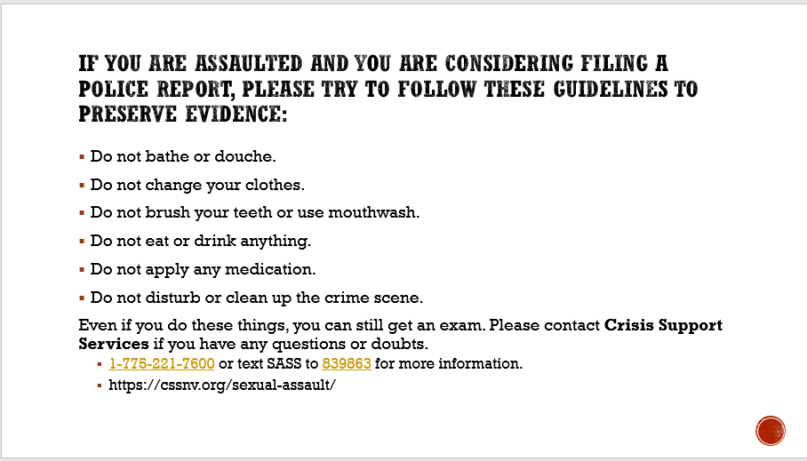

Slide 18:

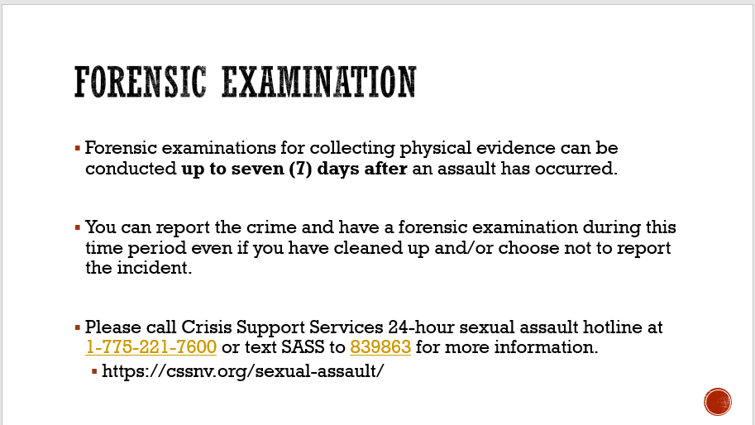

Slide 19:

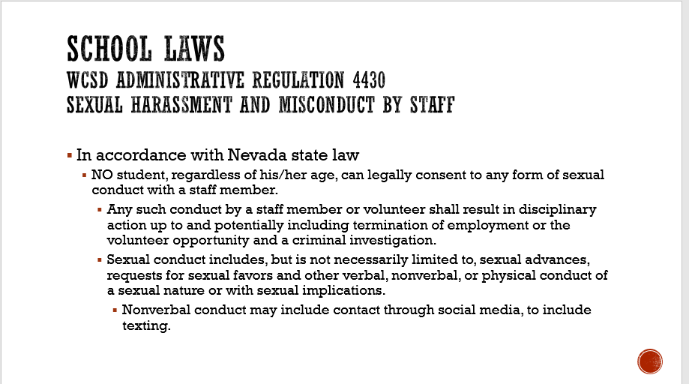

Slide 20:

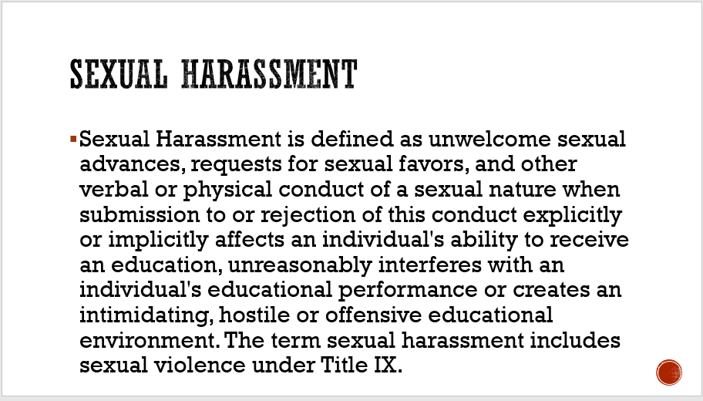

Slide 21

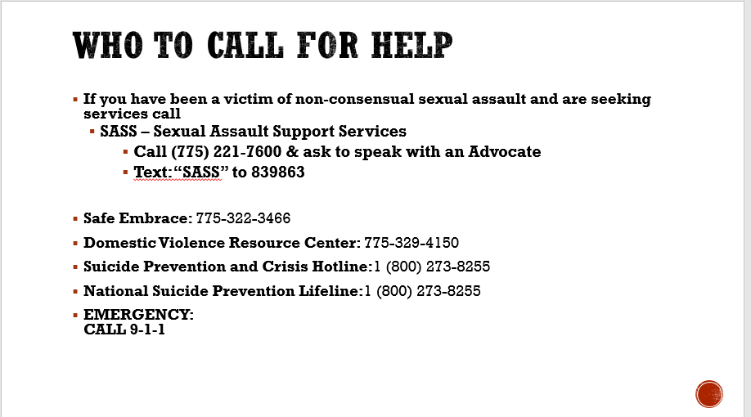

Slides 22-23:

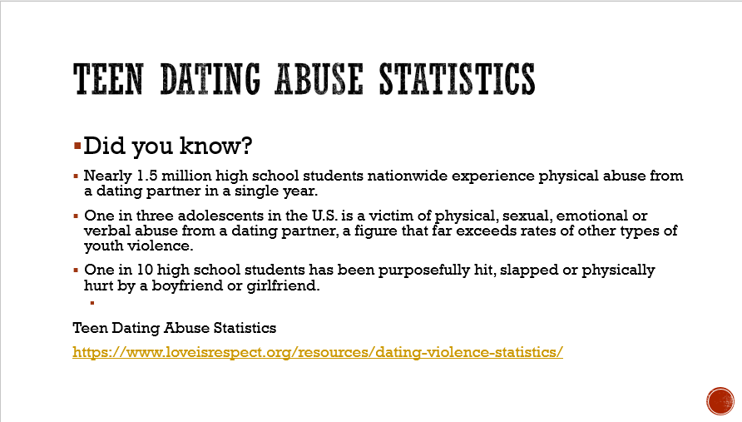

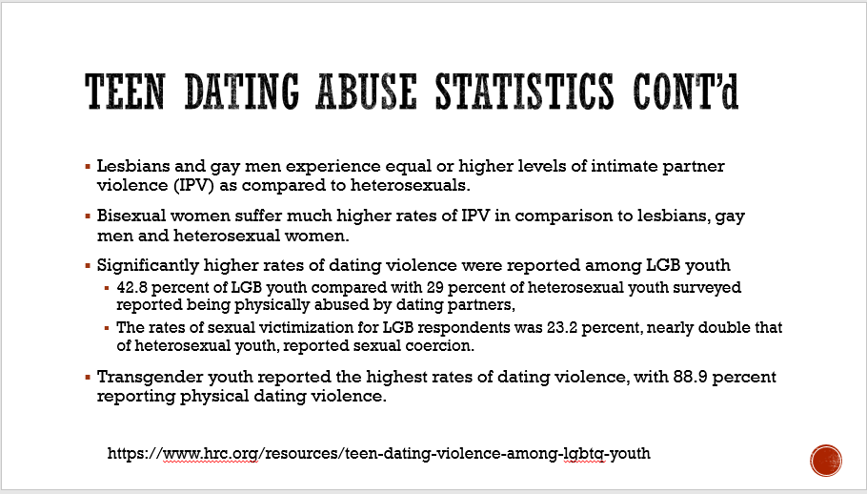

Did you know? – Teen Dating Abuse Statistics

(Loveisrespect.org: <https://www.loveisrespect.org/resources/dating-violence-statistics/>)

Slide 24:

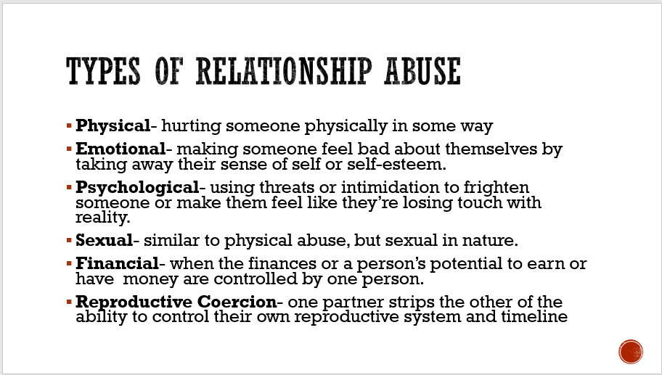

5 types of Relationship Abuse

Complete activity…

* As a whole group-brainstorm responses to each type and list responses on the board.
* If in groups, break class into 5 groups.

Post 6 posters around the room with one of the five types of abuse listed on each poster.

*either each group can work solely on their assigned topic or could do a “museum walk” and add something to each topic.

*Sample poster responses*

**PHYSICAL**

* Hitting
* Kicking
* Slapping
* Punching
* Pinching
* Restraining
* Choking
* Blocking their way

**EMOTIONAL**

* Criticizing the person’s appearance or intelligence
* Telling the person that no one else would ever want to be with them
* Flirting with other people in front of the person
* Using what they know makes the other person feel vulnerable in an attempt to make them feel worse
* Sharing sexy photos of the other person without their consent

**PSYCHOLOGICAL**

* Threatening to hurt the other person
* Threatening to hurt people they know or care about (or pets)
* Texting nonstop and expecting the other person to text back by a certain time
* Threatening to hurt yourself if the other person doesn’t do what you want
* Spreading rumors about the person

**SEXUAL**

* Rape
* Forcing the other person to do anything sexual they don’t want to do
* Making the other person watch porn
* Sharing sexy photos of the other person without their consent
* Refusing to practice safer sex

**FINANCIAL**

* Controlling the money in the relationship
* Stealing from the other person
* Telling the other person they need to spend time with you instead of going to work
* Keeping the other person from going to or finishing school, which limits their ability to

earn money

**REPRODUCTIVE COERCION**

* Refusing to use a condom or other type of birth control
* Breaking or removing a condom during intercourse
* Lying about their methods of birth control (ex. lying about having a vasectomy, lying about being on the pill)
* Refusing to “pull out” if that is the agreed upon method of birth control
* Forcing their partner to not use any birth control (ex. the pill, condom, shot, ring, etc.)
* Removing birth control methods (ex. rings, IUDs, contraceptive patches)
* Sabotaging birth control methods (ex. poking holes in condoms, tampering with pills or flushing them down the toilet)
* Withholding finances needed to purchase birth control
* Monitoring their partner’s menstrual cycles
* Purposefully trying to pass on a sexually transmitted disease
* Forcing pregnancy and/or not supporting their partner’s decision about when or if they want to have a child
* Forcing their partner to get an abortion, or preventing them from getting one
* Threatening their partner or becoming violent if they don’t comply with their wishes to either end or continue a pregnancy
* Continually keeping their partner pregnant (getting them pregnant again shortly after they give birth)

Say, “It can be relatively easy to come up with a list of behaviors – especially when we’re not in the relationship in the moment. However, sometimes abusive situations aren’t so clear.”

Slides 25:

What is a Healthy Relationship?

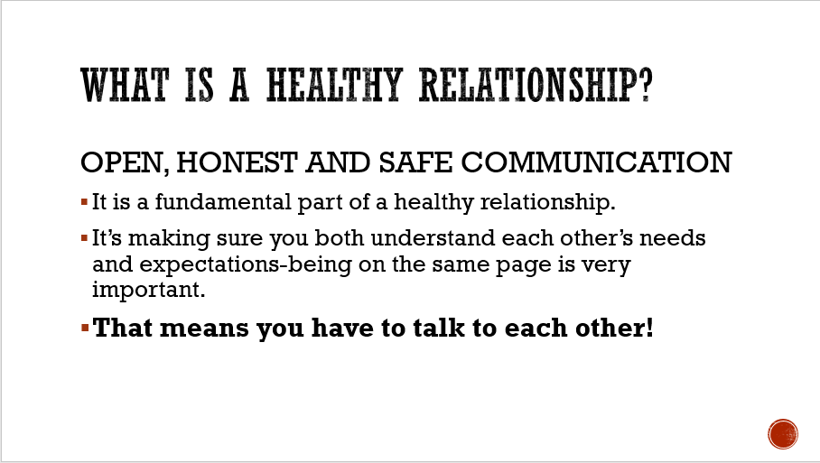

Slide 26: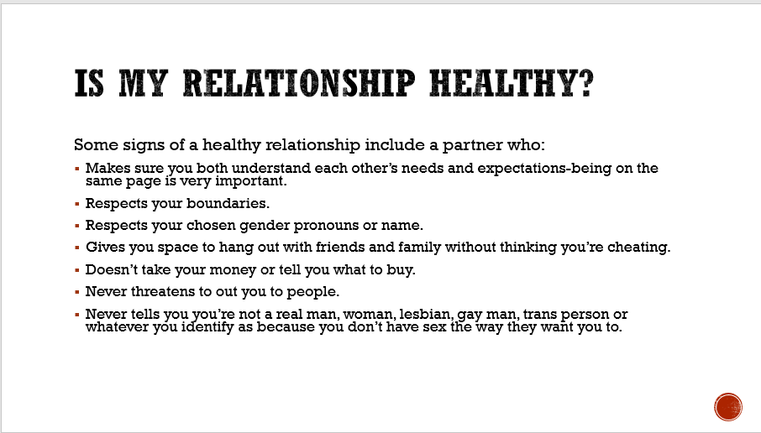

Slide 27:

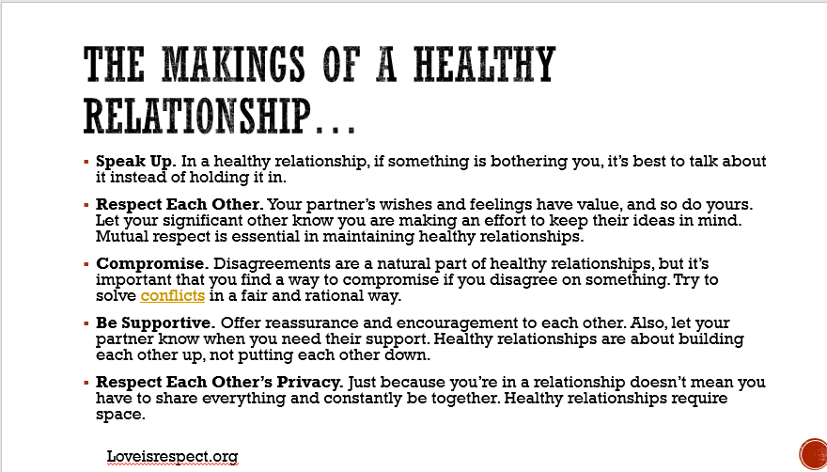 If You Think Your Relationship is Unhealthy

Slide 28:

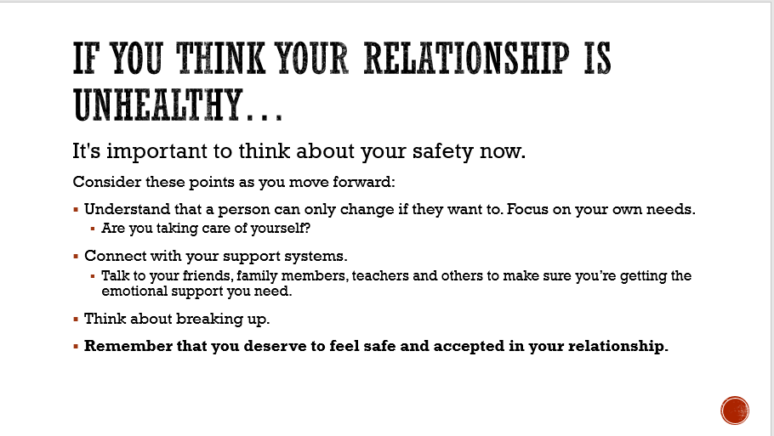

Whom to Contact for Help

Slide 29:

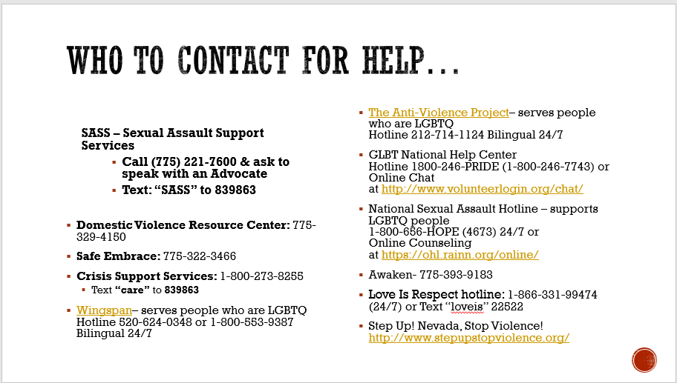

Slides 30-31

Is It Abuse If…?

*Note: The activity, “Is It Abuse If…?” was created by Elizabeth Schroeder, EdD, MSW, and then subsequently published in the American Journal of Sexuality Education in 2005. This*

*Is an adaptation of that activity. This activity has also been adapted and used as part of the Advocates for Youth curriculum.*

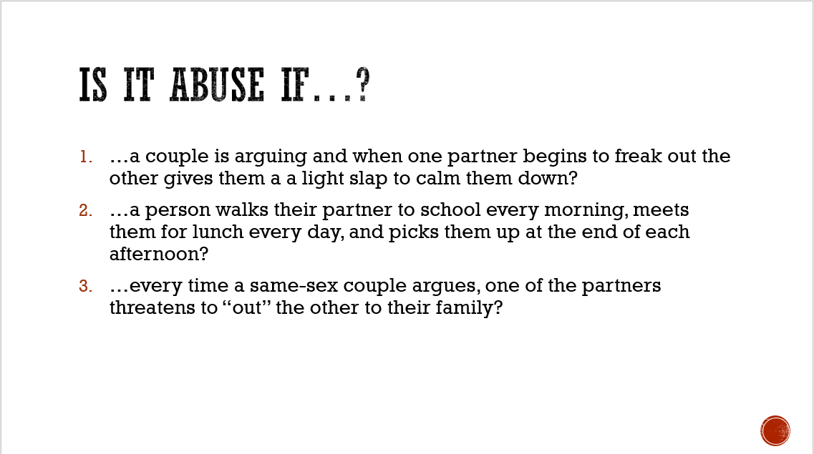

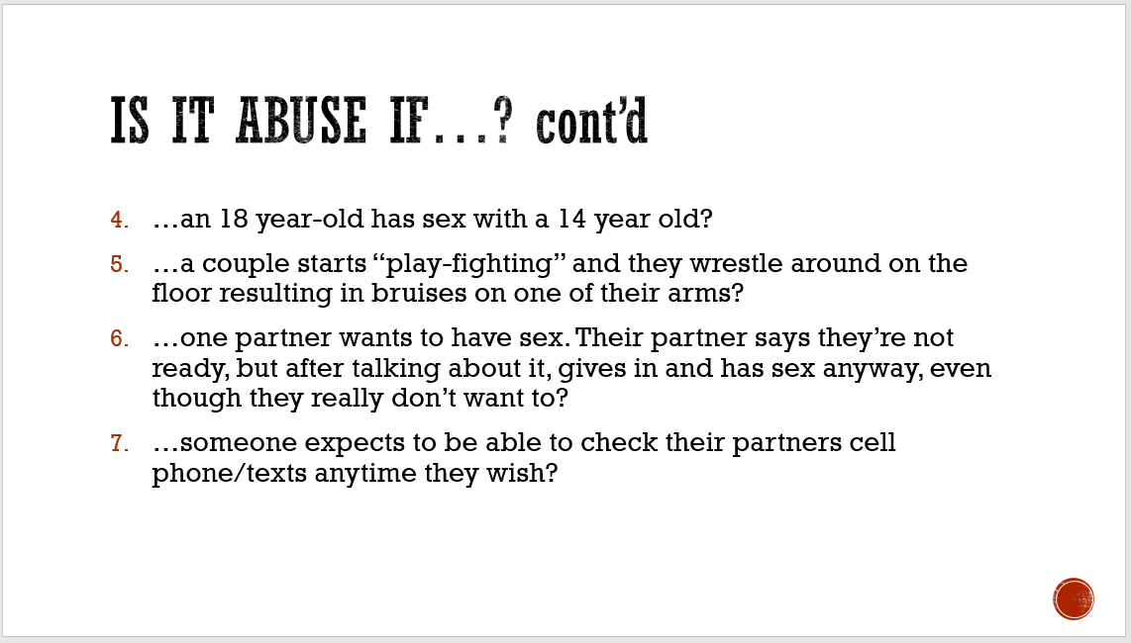

Slide 32:

“If you see something, Say something”

We’ve covered a lot of ground today, and if you are ever concerned about yourself or someone else, please, “Say Something!”

We have provided lots of resources both locally and websites for further information.

Don’t forget, a parent, trusted adult, school counselor, nurse, social worker, medical provider, faith based leader, talk to someone!

